**Website Design**

# Context: Uniform

## SWOT Analysis

|  |  |
| --- | --- |
| **Strengths** | **Weaknesses** |
| Show potential parents and caregivers what is available at the uniform shop. The website will also provide a way to see where the uniform shop is and how to access it. | It won't be useful to students that attend other schools. Another weakness will be if some parents don’t have a way to access the site such as not having a computer, phone or WIFI. |
| **Opportunities** | **Threats** |
| Help the parents and students know what uniform is available at Christchurch Boys High. It will also help the end user know when the hours of the shop is and how to access the shop. | Parents and students not having access to the website either by not having WIFI on not having a device to access the WIFI. |

# Purpose of the Website: The purpose if this website is to showcase the junior, senior and sports uniform that is available for purchase at the uniform shop. This Website will be helpful to students and parents wanting to know what uniform is available. The parents and students can use this website to quickly check if an item is something that is available for purchase at the shop. The website will also provide a way to check how to access the shop and when the hours are.

# End Users: The end users of this site are the parents, caregivers and students of Christchurch Boys High School. They would be able to use this website to quickly check what uniform is accessible from the uniform shop.

# Requirements of the End Users: The requirements of the end users are be able to access the website via the internet. This will mean having internet access to the internet. In 2018, 89 percent of New Zealanders were active users of the internet and many people that don’t have a local library that provides free WIFI. The last requirement is to be able to navigate a simple website.

# Implications

## Implication 1: Aesthetics

### How the website will look and if it will appeal to the general public and the end user/s of the site. This is important because if the end users don’t find the website to be aesthetically pleasing, they may not want to use the site and it can also distract from the content on the site.

The survey that I created address the implication and finds out what design the end user finds aesthetically pleasing.

## Implication 2: Functionality

### How the website will function and if Evey link will work. If the Public find it easy to navigate through the website. This is Important because if the website is not functional then the target users will not be able to use the website making it useless.

This will be addressed by getting feedback and if my classmates find it easy to navigate through the site and if the links work.

## Implication 3: legal

### The legal aspect of the website. Is all the content legal and able to be used? Such as copy right on different images. This is important because if the correct steps are not taken to make sure the website is legal and have access to the images then it is against the law. The New Zealand law copy right act 1994 states that if someone is convicted, they can be charged up to $150,000 or be imprisoned for up to 5 years

This will be addressed by emailing the owners of the images if it is ok to use them on my uniform website.

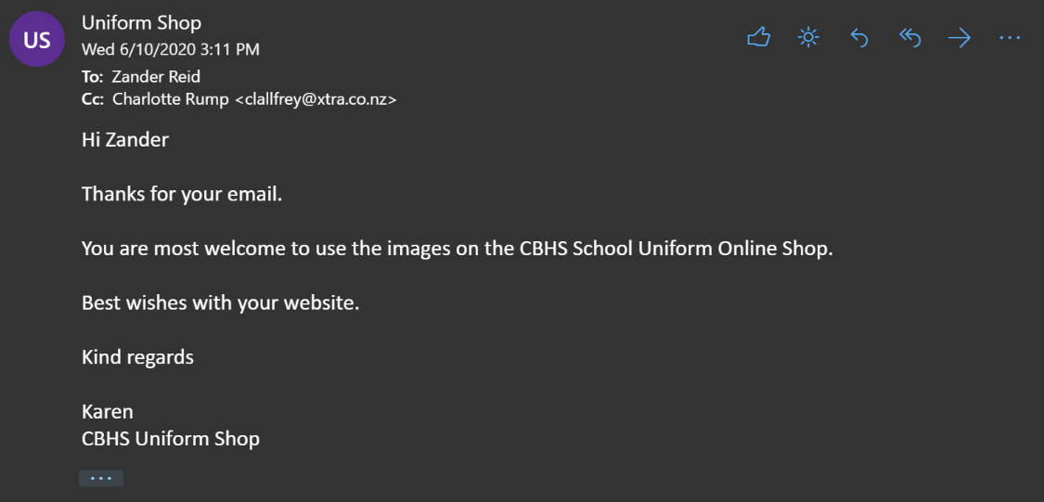

Website design feedback:

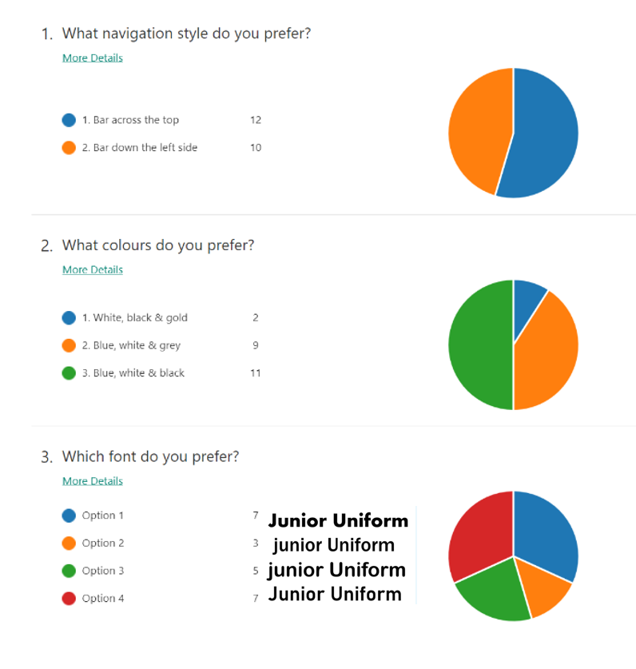

# Design concepts

# Design Concept 1 **<----ctrl + click for link to PowerPoint**

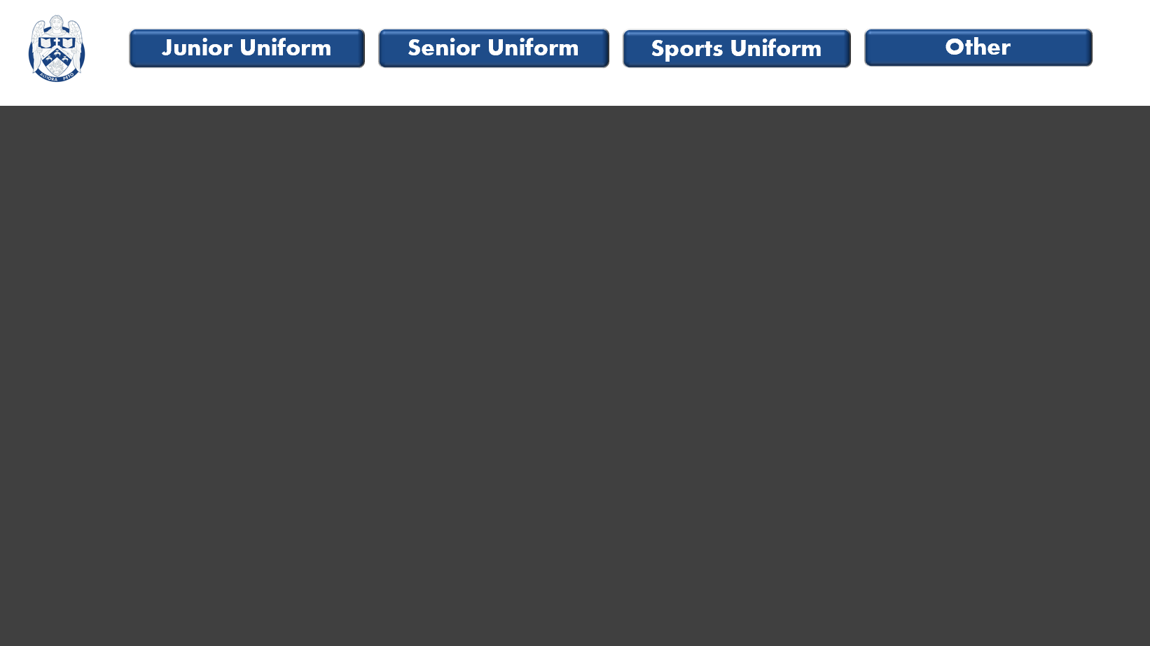

## Navigation: Bar across the top with links to the different year levels uniform, senior, junior and sporting uniforms.

## Colour Scheme: grey background, a white navigation bar with blue boxes for the links

## Feedback: for the navigation the bar across the top won 12 votes to 10. The colour scheme grey, white and blue got 2nd place with 9 votes.

# **Design Concept 2** **<----ctrl + click for link to PowerPoint**

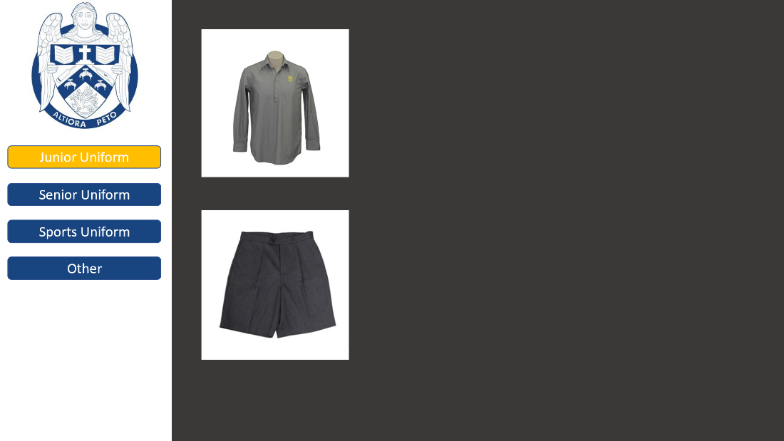

## Navigation: bar down the side with links to the different year levels uniform, senior, junior and sporting uniforms.

## Colour Scheme: grey background with a white navigation bar and blue boxes with links down the side.

## Feedback: bar down the side lost 10 votes to 12, the colour scheme was not somewhat liked with 9 votes.

# Design Concept 3 **<----ctrl + click for link to PowerPoint**

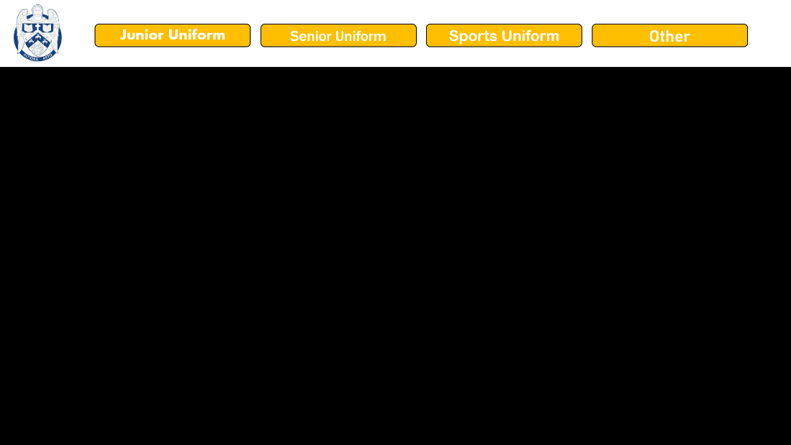

## Navigation: Bar across the top with links to the different year levels uniform, senior, junior and sporting uniforms.

## Colour Scheme: black background with a white navigation bar and gold boxes with links.

## Feedback: Colour scheme got the least votes with 2 but the top bar was preferred.

# Final Design **<----ctrl + click for link to PowerPoint**

## Feedback: The feedback that I received was all put together to make this final design. bar across the top won 12 votes to 10, blue white and grey was 2 with 9 votes.

## Improvements to Design: the improvements I have made is change the colours to the more preferred option of black and white with blue navigation boxes across the top as a bar. I have also changed the font to the font preferred by 7 people, Aharoni. All the changes that I have made were in result of the feedback my survey generated. Feedback bellow. Another change that I also mad was change the number of pages and what was on them. Originally, I had 5 pages including the welcome page. I decreased this to 4, removing the “other” and “sports” uniform pages in favour of a location page.

Final design: I have chosen this design because it was the most liked the people that took the survey (students in DTC class). I believe that this will be the best design to develop because students are one of the main target end users.